**Implement Undirected Graph API.**

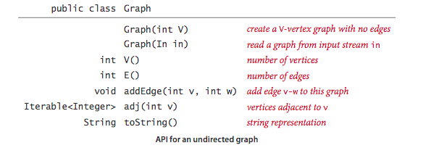

**Input Format :**

First line of input contains keyword “List” or “Matrix”, which represents Graph using Adjacency List or Adjacency Matrix.

Second line of input contains number of Vertices.

Third line of input contains number of Edges.

Fourth line contains the key names which are separated by comma.

From fifth line onwards, each line contains two vertices (Integers) separated by space, that indicates the keys are to be connected. (The number of edges indicates the number of lines.)

**Output Format:**

**For Adjacency List Representation :**

First line contains count of vertices, count of Edges.

From second line, print the key and its adjacent keys separated by colon. Add space to separate adjacent cities.

**For Adjacency Matrix Representation :**

First line contains count of vertices, count of Edges.

Print the V * V binary matrix, where it contains 0’s and 1’s. If there is a path, print 1 otherwise 0.

**Note:**

1. While adding edges in a graph, don’t add self loop and parallel edges.
2. While printing the output, Use Bag.java to store adjacent vertices, to print them in output order.
3. For case of Adjacency List, print the key names and it adjacency key names.
4. For case of Adjacency Matrix, print the V*V binary matrix, which contains 0 or 1. If there is an edge print 1 else 0.
5. For a Undirected Graph, if edges are 0, print “No edges”.